# Design Brief

## App Description

It is a social media app that allows people to debate topics using various utilities with a goal to allow users to create threads or debates that people can vote on the provided options, having only 1 vote per user on any particular topic.

A pie chart or bar chart will then be provided allowing users to visualise the topics option approval.

The users will be allowed to participate in a chat forum below the charts showing what the user voted for beside their name when they do post on the chat.

Each users comment can be voted up and it can display the top voted comment of each opinion on the top for users to get a idea of the best reasons why each user voted for the option they did vote for.

Each user will have to create an account in order to participate in debates information such as how many debates they have voted or commented on.

On the main page it will show the top trending topics/debates, a topic search option, which will bring you to the search page to search debate by topic.

When creating a topic/debate, you name the debate, select the topic and allocate the selectable options for participants.

The information regarding the threads and user will be stored on a database. This information can also be used to provide information such as the top trending topics at the moment based on on how many users have voted on the app in the recent week.

## Use Case Diagram

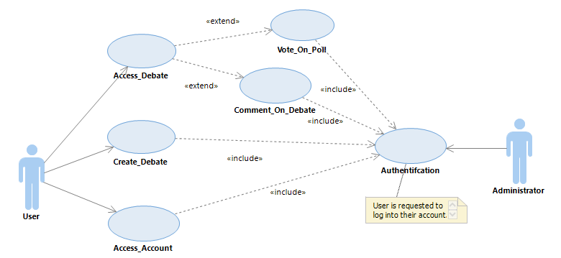

## Database Diagram

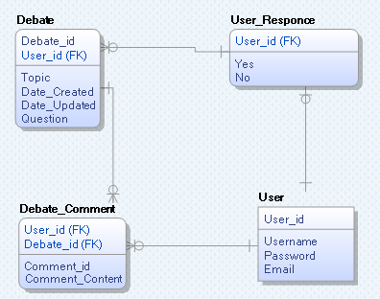

In the User account screen, a select statement will be used to return the number of comments and the number of polls the user have posted on, returning a link as well to the debate that was posted on commented on.

## Screen Flow Diagram

